

SCRIPT INSTALLATION GUIDE
- introduction
- checking connection
- creating user
- checking j2 image
- j2 cloning and image installation
INTRODUCTION
This is a step by step procedure on how to install scripts. The scripts have been embedded in the new image which has drivers for all J2 touchscreens.
TOOLS
- Laptop
- Ethernet cable
- Keyboard
- Mouse
- inverter

CHECKING SITE CONNECTION
Make sure the system is up and running. The following things are crucial and must be powered at each and every site during this exercise. The radio,laptop and the touchscreen(J2).Check if the site is able to connect to the server and to the router. Open the terminal and type the following commands;
- Router: ssh <ip address>
- server: Ping 192.168.21.254
:ssh 192.168.21.254
The ssh commands will need fingerprints. You should always give a positive answer (yes) to the question that follows. Then,it will ask you for password to log in(You will be given the password) .
Log out and try to log in again,this time both the router and the server must not look for fingerprints. This ensures that there is no connectivity problem both to the router and server.

CREATING THE USER
Set up user called user on the router. as shown in the picture below:

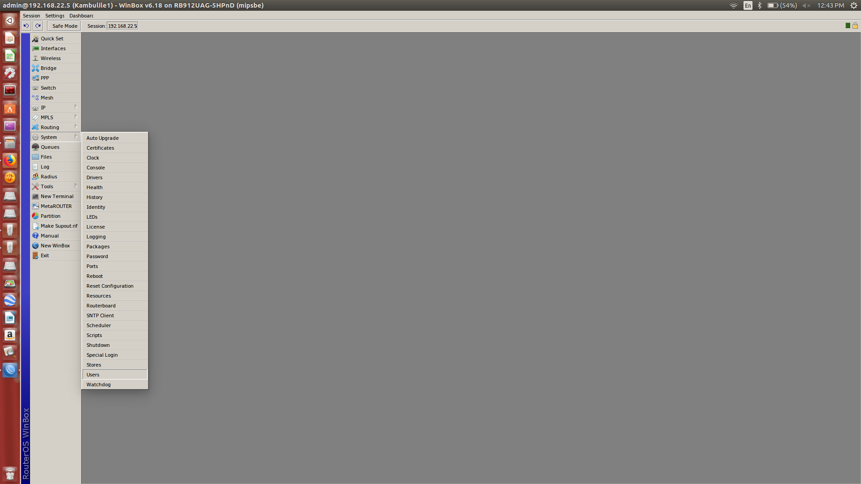
Thus,open win box and log in. Click on systems and then user. Create the user with the following privileges;Read only, must have a password-less login and it must be limited to internal users only

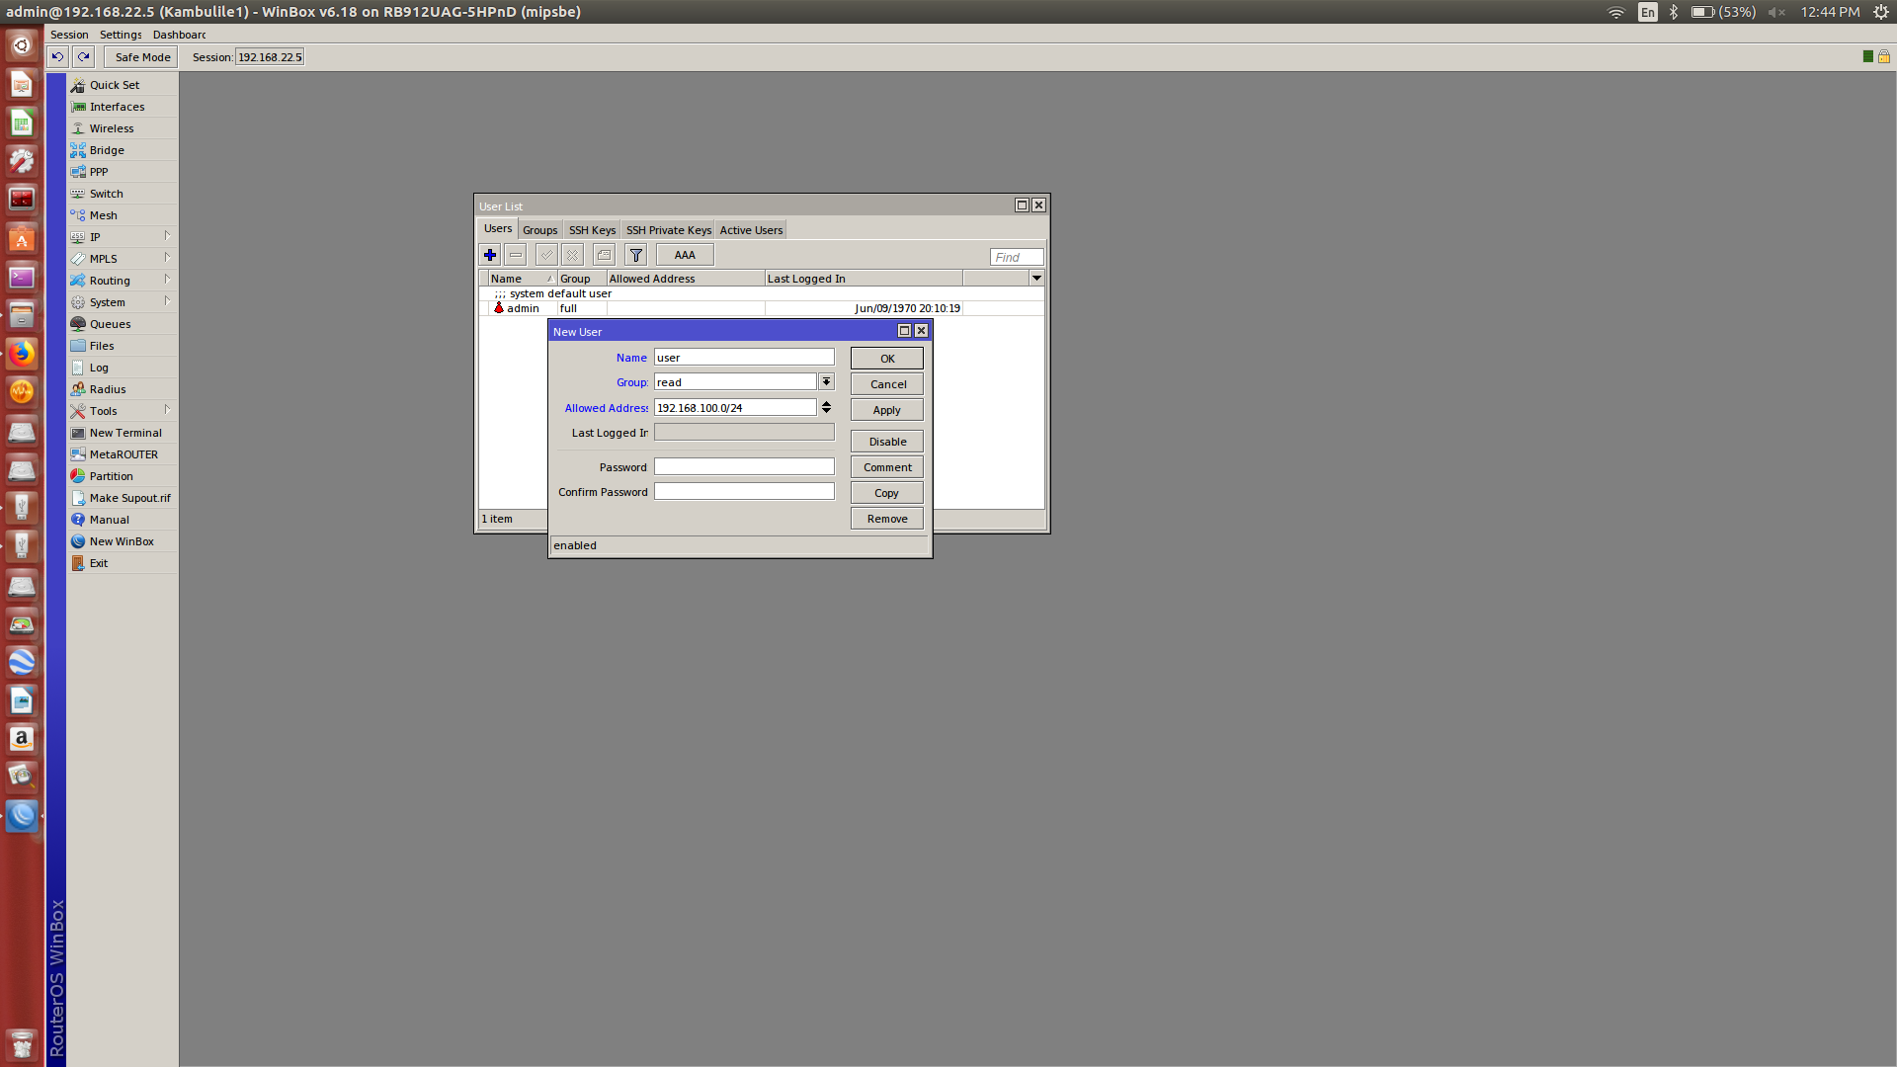
CHECKING THE TOUCHSCREEN IMAGE
The harmonized image contain evr-indicators folder. Therefore, open the terminal and check if this folder is present. Type ls to see all the folders available in the touchscreen computer.

J2 TOUCHSCREEN CLONING AND IMAGE INSTALLATION
Connect the cable from your laptop to the touchscreen. Clone the j2 touchscreen using “zammudzi-for-all”image if the folder mentioned above is not available. Refer to operations directorate for the manual on how to clone the j2.Then,open the terminal and check for the folder again.
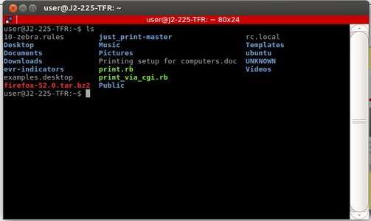

Remember that the scripts can only run in evr-indicators directory. Therefore you need to change the directory to evr-indicators to run them. This can be done by using the command below;
sudo ./evr-indicators.sh or bash -x evr-indicators.sh
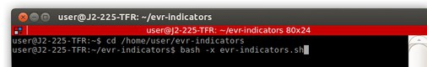
After that,check if there is a folder bearing the village name in the evr-indicators directory
/home/user/evr-indicators
Copy the folder of that village to your laptop. To do this,firstly compress the folder by using the following command
tar -cvf evr-indicators.tar evr-indicators/
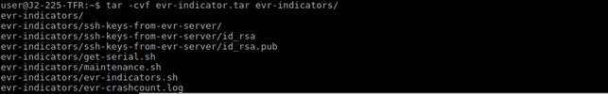
Then rsync the folder to your home folder. Use the command shown below;
rsync evr-indicators.tar <home-folder>@< ip address>:/home/<home-folder>
Lastly,make sure that the saved folder has the name of the site in your home-folder.
NOTE: Thou shall not make a typing error!!!

ENJOY ! ! !

